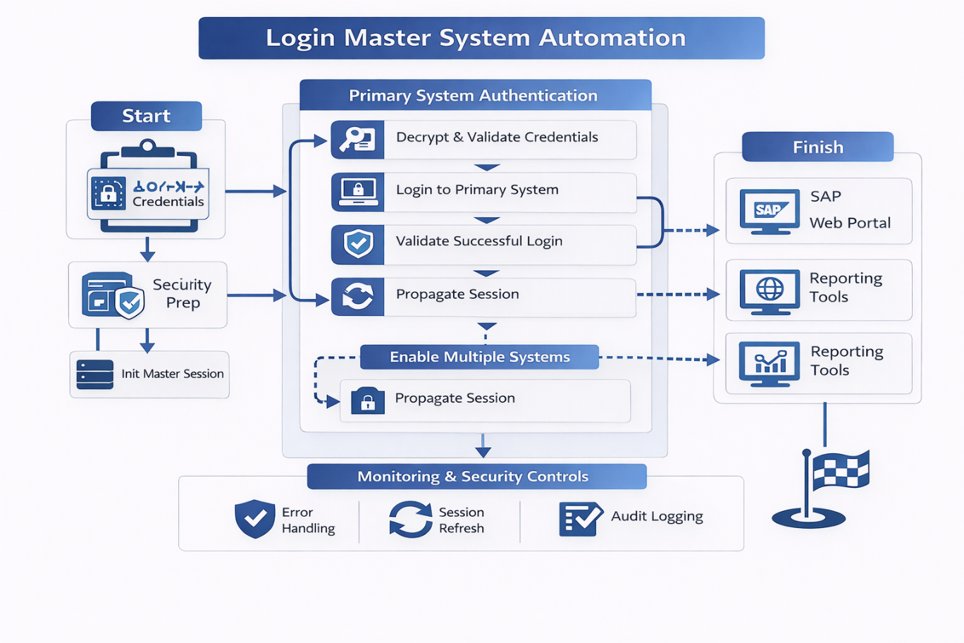
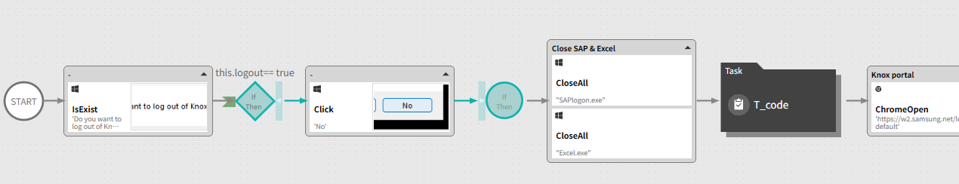

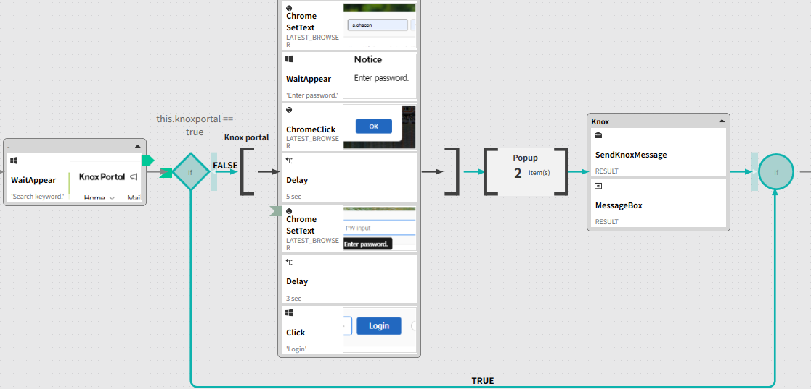

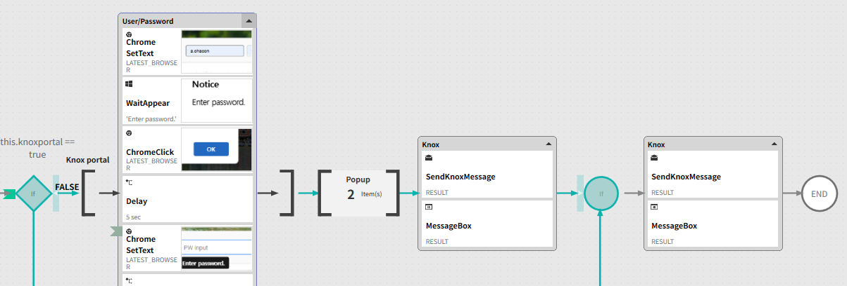

🎯 Business Problem
Accessing multiple enterprise systems required repetitive manual logins and presented several risks:
- Manual authentication into multiple systems
- Credential handling dependency on users
- Execution delays due to session timeouts
- Inconsistent login flows across platforms
- High failure rate in chained automations
This limited scalability and reliability of multi-system automation workflows.

🧠 Solution Overview
A Master Login Automation was designed to authenticate once and securely enable access to multiple downstream systems (SAP, web portals, internal tools, reporting platforms).
The solution standardizes login logic, manages sessions, and provides a reusable authentication layer for other RPA processes.

🖼 RPA Orchestration Breakdown
- Initialization & Security Setup
  - Load encrypted credentials and environment parameters
  - Prepare execution context and security policies
- Master Login Execution
  - Authenticate into primary system
  - Validate successful session creation
- Session Propagation
  - Reuse authenticated session to access secondary systems
  - Validate access permissions per system
- Downstream System Enablement
  - Open and validate access to additional platforms
  - Hand over active sessions to dependent automations
- Monitoring & Control
  - Monitor session health and timeouts
  - Refresh or re-authenticate if required
- Safe Closure
  - Controlled logout from all systems
  - Secure session termination and logging

📊 Results & Business Impact
- Faster startup of multi-system automations
- Reduced login-related failures
- Improved security and credential governance
- Higher automation scalability
- Consistent execution across environments

🔍 Before vs After
Before
- Manual login per system
- Credential exposure risk
- High failure rate in chained automations
- Slow automation startup
After
- Single master authentication flow
- Secure credential handling
- Stable multi-system access
- Faster and more reliable executions

🧩 Key Features
- Centralized authentication logic
- Secure credential management
- Session reuse across systems
- Validation and recovery mechanisms
- Reusable component for other automations

🛠 Tech Stack
- RPA Orchestration Platform
- Python (security logic, session handling)
- SAP GUI / Web automation
- Credential vault / secure storage
- Logging and monitoring tools

🧠 Challenges & Design Decisions
- Credential security → Enforced encryption and vault usage
- Session consistency → Implemented validation and refresh logic
- Multi-system variability → Modular login handlers per platform
- Automation chaining → Designed as reusable core component

👤 My Role
- RPA Solution Architect
- Designed centralized authentication architecture
- Implemented secure login and session reuse logic
- Integrated master login with downstream automations
- Ensured enterprise-grade security standards

🚀 Why This Project Matters
This project enables scalable, secure, and reliable automation ecosystems, proving that authentication is not just a technical step but a foundational enabler for enterprise RPA architectures.

